400 Watts
MONOCRYSTALLINE SOLAR MODULE

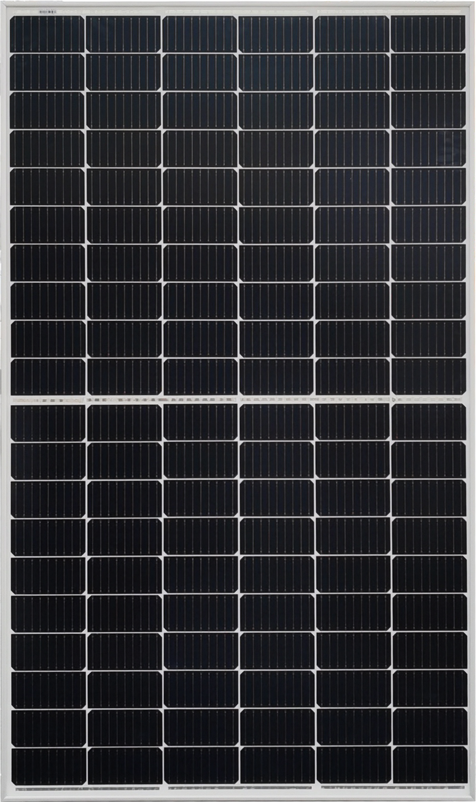

Products features:
- High efficiency cell
- Multi-bus grid technology
- Strong aluminum alloy frame
- Standard tolerance (Guaranteed standard tolerance from -3~+3% ensures power output reliability)
- Excellent weak light performance
Excellent performance under low light environments (mornings, evenings, and cloudy days)
- Withstand high wind and snow loads
Entire module certified to withstand high wind loads (2400 Pascal) and snow loads (5400 Pascal)

Electrical Characteristics
Model No. | SFM-400W
Maximum Power at STC (Pmax) | 400W
Optimum Operating Voltage (Vmp) | 34.3V
Open - Circuit Voltage (Voc) | 41.6V
Optimum Operating Current (Imp) | 11.66A
Short - Circuit Current (Isc) | 12.83A
Cell Efficiency | 20.5%
Operating Module Temperature | -40 °C to +85 °C
Maximum System Voltage | 1000 V DC (IEC) / 600 V DC (UL)
Diodes | 3 by pass
Power Tolerance | -3/+3 %
STC: irradiance 1000 W/m², module temperature 25 °C, AM=1.5; Power measurement tolerance: ± 3%
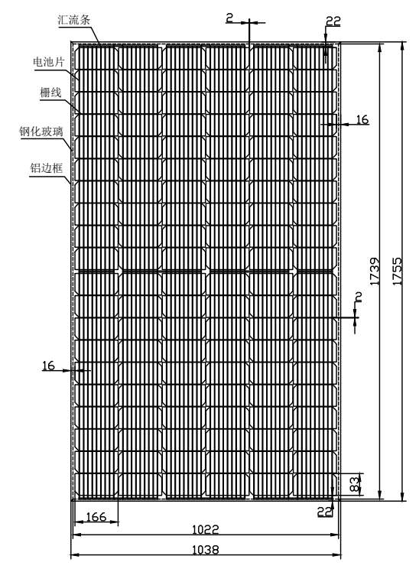

Mechanical Characteristics
Solar Cell | Monocrystalline 166*83mm
No. of Cells | 120(6× 20)
Dimensions | 1755*1038*35 mm
Weight | 20Kgs
Front Glass | 3.2 mm (0.13 inches) tempered glass
Frame | Anodized aluminum alloy
Junction Box | IP65 rated
Output Cables | TUV
Output Cables | 4.0 mm2 (0.16inches2), symmetrical lengths (-) 900 mm (35.4 inches) and (+) 900 mm (35.4 inches)
Connectors | RADOX® SOLAR integrated twist locking connectors

Temperature Characteristics
Nominal Operating Cell Temperature (NOCT) | 45±2 ℃
Temperature Coefficient of Pmax | -0.35%/℃
Temperature Coefficient of Voc | -0.276%/℃
Temperature Coefficient of Isc | 0.045%/℃

Quality and Safety:
Product warranty:
Singfo Solar modules will last for at least 25 years.
Free from defects in material and workmanship for 5 years.
All the panels passed IEC, TUV standards.
Power warranty:
Maintain more than 90% of minimum rated power for 10 years.
Maintain more than 80% of minimum rated power for 25 years.

