450 Watts
MONOCRYSTALLINE SOLAR MODULE

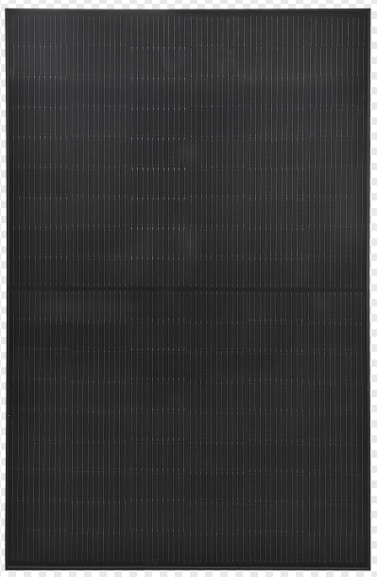

Products features:
- Half Cut Bifacial Solar panel
- Strong aluminum alloy frame
- Standard tolerance (Guaranteed standard tolerance from -5~+5% ensures power output reliability)
- Excellent weak light performance
Excellent performance under low light environments (mornings, evenings, and cloudy days)
- Withstand high wind and snow loads
Entire module certified to withstand high wind loads (2400 Pascal) and snow loads (5400 Pascal)
Model No. | SFM450W-108
Maximum Power at STC (Pmax) | 450 W
Optimum Operating Voltage (Vmp) | 31V
Open - Circuit Voltage (Voc) | 37.2V
Optimum Operating Current (Imp) | 14.52A
Short - Circuit Current (Isc) | 15.97A
Operating Module Temperature | -40 °C to +85 °C
Maximum System Voltage | 1000V
Diodes | 3 by pass / 6 by pass
Power Tolerance | -5/+5%

Mechanical Characteristics
Solar Cell | Monocrystalline 166×83 mm
No. of Cells | 108(2 ×54)
Dimensions | 1722*1134*30mm
Weight | 20.5Kgs
Front Glass | 3.2 mm (0.13 inches) tempered glass
Frame | Anodized aluminum alloy
Junction Box | IP68 rated
Output Cables | TUV
Output Cables | 4.0 mm2 (0.16inches2), symmetrical lengths (-) 22 mm 8.66 inches) and (+) 22mm (8.66inches)
Connectors | RADOX® SOLAR integrated twist locking connectors
STC: irradiance 1000 W/m², module temperature 25 °C, AM=1.5; Power measurement tolerance: ± 5%

Temperature Characteristics
Nominal Operating Cell Temperature (NOCT) | 45±2 ℃
Temperature Coefficient of Pmax | -0.47%/℃
Temperature Coefficient of Voc | -0.34%/℃
Temperature Coefficient of Isc | 0.045%/℃

uality and Safety:
Product warranty:
Singfo Solar modules will last for at least 25 years.
Free from defects in material and workmanship for 5 years.
All the panels passed IEC, TUV standards.
Power warranty:
Maintain more than 90% of minimum rated power for 10 years.
Maintain more than 80% of minimum rated power for 25 years.

