550Watts
MONOCRYSTALLINE SOLAR MODULE

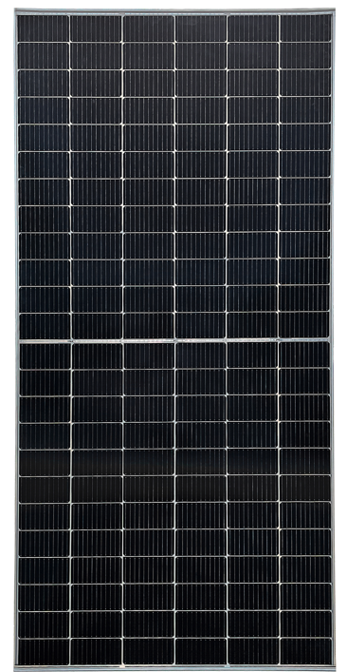

Products features:
- Half Cut Bifacial Solar panel
- Strong aluminum alloy frame
- Standard tolerance (Guaranteed standard tolerance from -5~+5% ensures power output reliability)
- Excellent weak light performance
Excellent performance under low light environments (mornings, evenings, and cloudy days)
- Withstand high wind and snow loads
Entire module certified to withstand high wind loads (2400 Pascal) and snow loads (5400 Pascal)

Power parameters
Model No. | SFM-550W
Maximum Power at STC (Pmax) | 550W
Optimum Operating Voltage (Vmp) | 41.95V
Open - Circuit Voltage (Voc) | 49.8V
Optimum Operating Current (Imp) | 13.12A
Short - Circuit Current (Isc) | 13.98A
Operating Module Temperature | -40 °C / +85 °C
Maximum System Voltage | 1500V
Diodes | 0 to 100%
Power Tolerance | 3 by pass
Maximum Power at STC (Pmax) | -3/+3 %
STC: irradiance 1000 W/m², module temperature 25 °C, AM=1.5; Power measurement tolerance: ± 5%
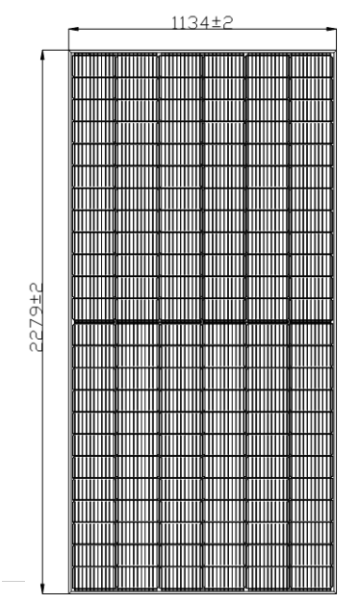
Mechanical Characteristics
Solar Cell | Monocrystalline 182*91mm
No. of Cells | 144(6× 24)
Dimensions | 2279*1134*35*35 mm
Weight | 27.3Kgs
Front Glass | 3.2 mm (0.13 inches) tempered glass
Frame | Anodized aluminum alloy
Junction Box | IP68 rated
Output Cables | TUV
Output Cables | 4.0 mm2 (0.16inches2), symmetrical lengths (-) 22 mm 8.66 inches) and (+) 22mm (8.66inches)
Connectors | RADOX® SOLAR integrated twist locking connectors

Temperature Characteristics
Nominal Operating Cell Temperature (NOCT) | 45±2 ℃
Temperature Coefficient of Pmax | -0.35%/℃
Temperature Coefficient of Voc | 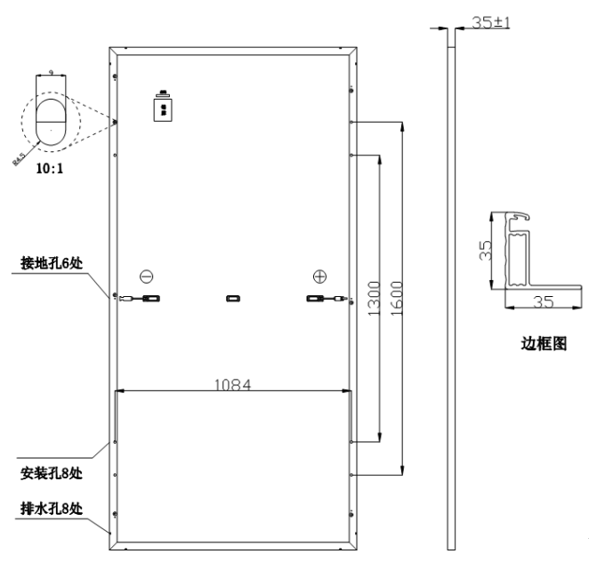  -0.276%/℃
Temperature Coefficient of Isc | 0.046%/℃

uality and Safety:
Product warranty:
Singfo Solar modules will last for at least 25 years.
Free from defects in material and workmanship for 5 years.
All the panels passed IEC, TUV standards.
Power warranty:
Maintain more than 90% of minimum rated power for 10 years.
Maintain more than 80% of minimum rated power for 25 years.

